Prompt
Remove the vehicle registration number from the JCB details/header.
Currently it shows:
JCB-01 TN-23-AX-1234
Change it to show only:
JCB-01
Requirements:
- Remove the registration number (TN-23-AX-1234) from the header.
- Keep the JCB machine ID/name such as JCB-01.
- Do not display the registration number anywhere in this header section.
- Keep the existing subtitle: “Real-time service intervals, oil grade specs & hour meter log”.
- Maintain the current UI design and spacing after removing the registration number.

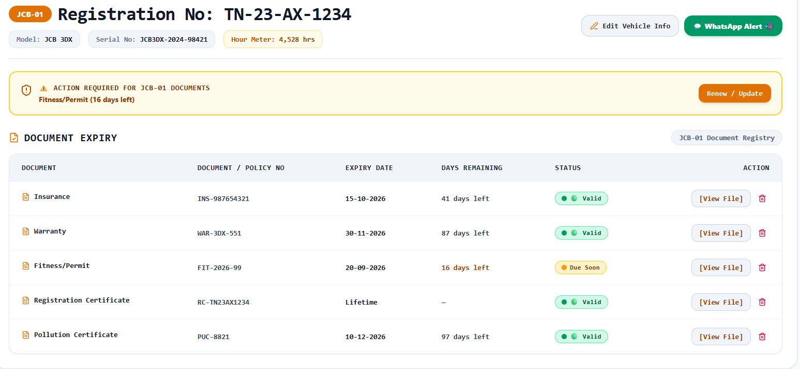

Prompt
Update the JCB Next Services / Hour Meter section with the following service intervals and make them configurable.
Default Service Intervals
Set the default interval for each service as:
- Engine Oil → Every 300 hours
- Hydraulic Oil → Every 3,000 hours
- Air Filter → Every 300 hours
- Greasing → Every 300 hours
- Lubrication Oil → Every 300 hours ← Add this new service
The service due/remaining hours should be calculated automatically based on the current hour meter and the last service hour.
Lubrication Oil
Add a new Lubrication Oil service card alongside the existing services.
It should have the same functionality as Engine Oil, Hydraulic Oil, Air Filter, and Greasing:
- Current hour meter
- Next service due hour
- Hours remaining
- Progress bar
- Schedule Service button
- Service history tracking
Edit Service Interval
Add an Edit / Settings option so the user can change the default service interval for each service.
For example:
- Engine Oil: 300 hrs → user can change to 500 hrs
- Hydraulic Oil: 3000 hrs → user can change to 2500 hrs
- Air Filter: 300 hrs → user can change to 400 hrs
- Greasing: 300 hrs → user can change to 250 hrs
- Lubrication Oil: 300 hrs → user can change to 500 hrs
When the interval is changed, the next service due and remaining hours should automatically recalculate.
Important
- Save the customized interval for each individual JCB machine.
- Do not use one global interval for all machines.
- Service intervals must persist after page refresh.
- When the hour meter is updated, automatically recalculate all service statuses.
- Show OVERDUE when the current hour meter has passed the service-due hour.
- After completing/scheduling a service, record the current hour meter as the last serviced hour and calculate the next service based on the configured interval.
Default configuration:
Engine Oil: 300 hrs | Hydraulic Oil: 3000 hrs | Air Filter: 300 hrs | Greasing: 300 hrs | Lubrication Oil: 300 hrs
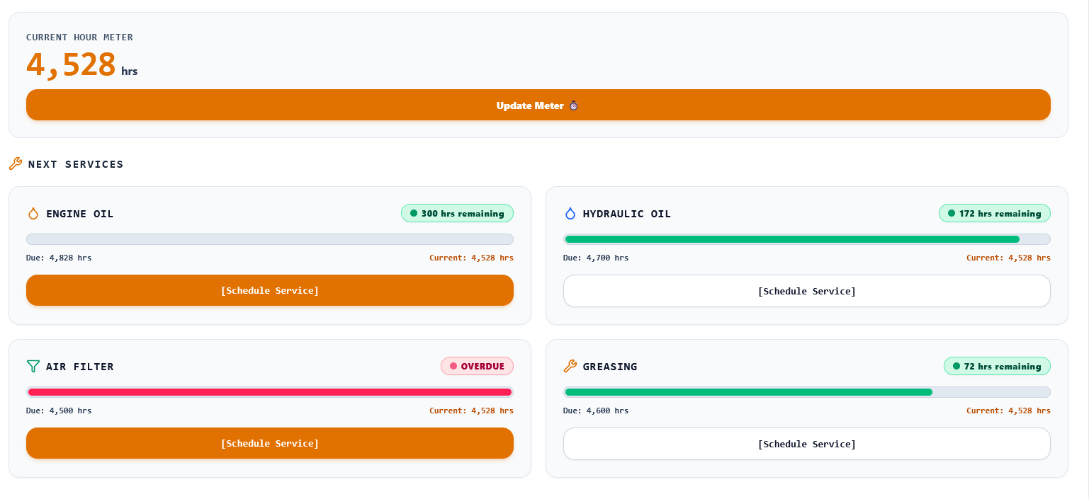

Here keep only j1 j2 likewise not reg no. 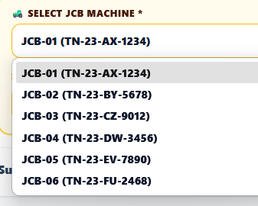

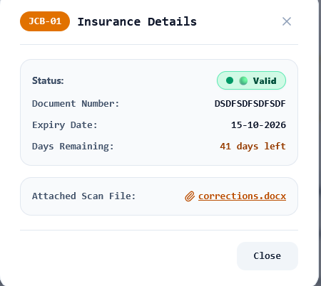option to view attached document

Set the Cost (₹) field to 0 by default instead of 8500.
So the default should be:
Cost (₹) * → 0
The user can then manually enter the actual cost when needed.
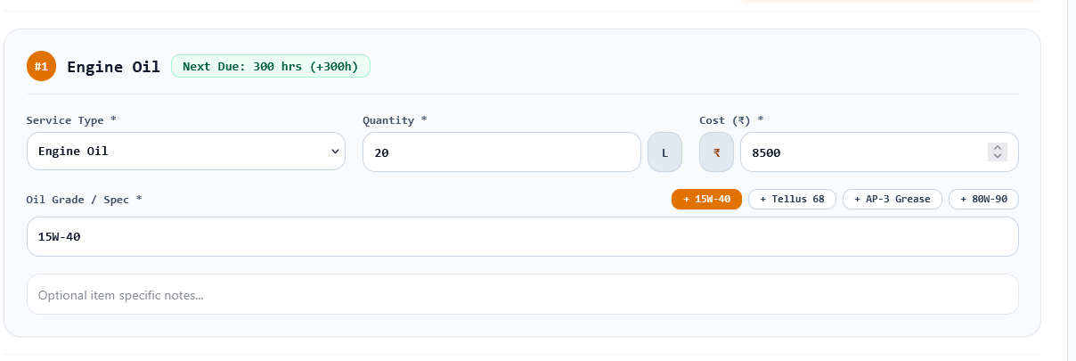

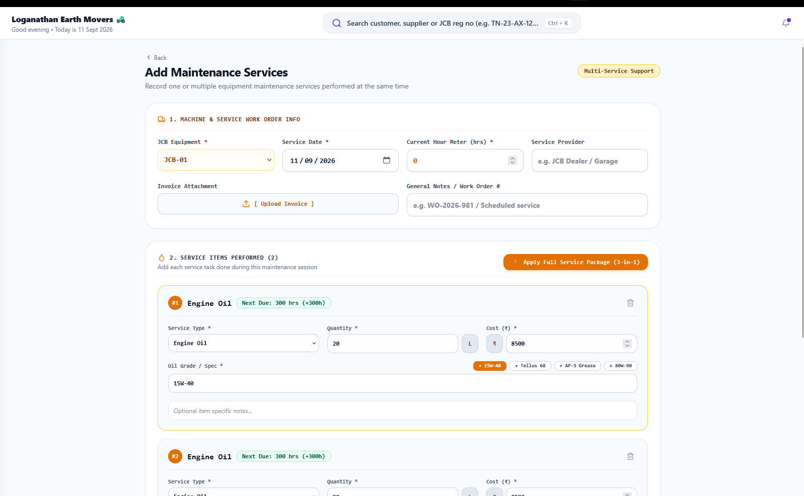
Make it bigger font

